**Project 2**

Using Mockaroo.com I created three tables as suggest in mini project 2 instructions document.

* Shipment – contains order details of the customers
* Item – Contains product details
* Customer – Contains Customer details

Below are the tables in Mockroo website

Shipment:

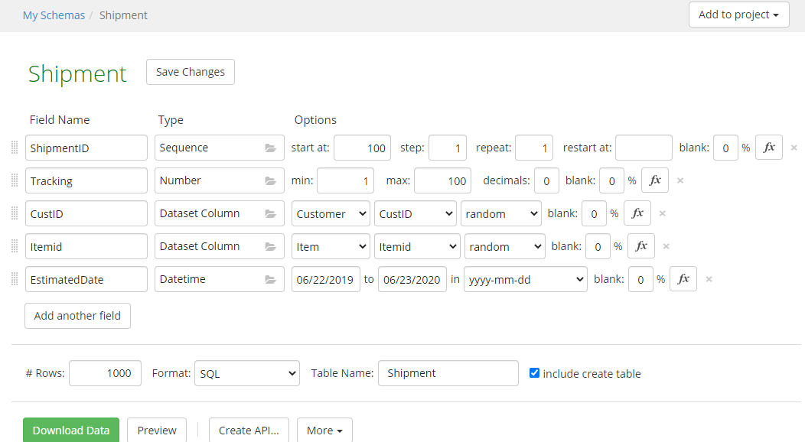

Item:

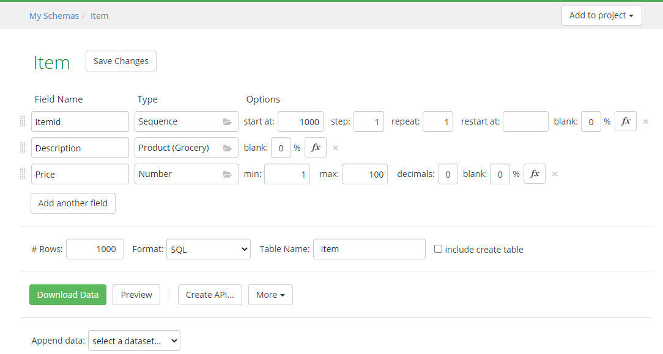

Customer:

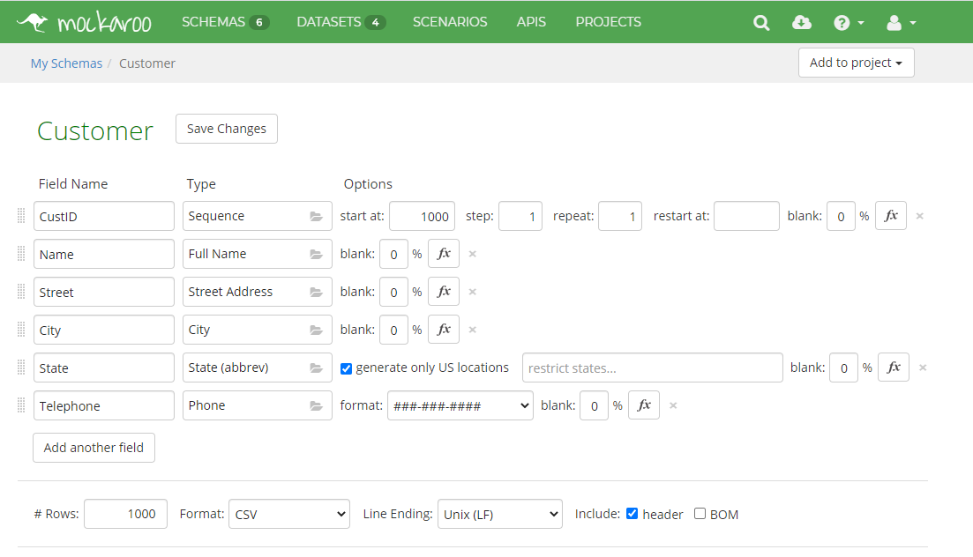

Please find the schema attached here. (I added separately while submitting assignment)



I loaded these schemas in EC2 instance. Below are table details inside instance.

Please find the table details in EC2 instance.

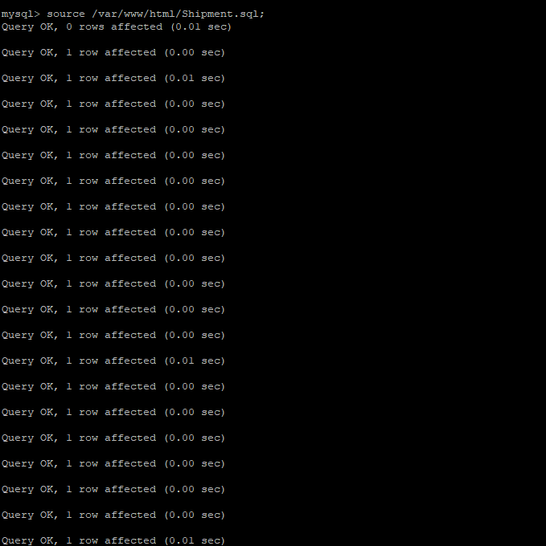

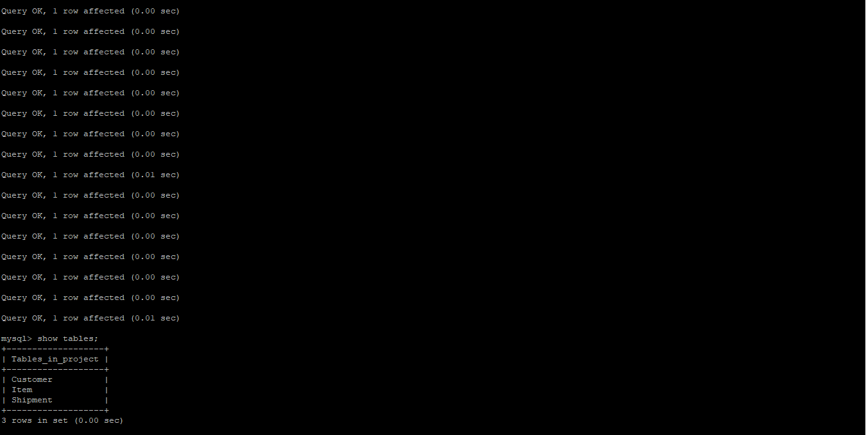

Then I added Ajax web pages as asked in the project instruction document.

I added a demo page (demo3.html) where I have “Name” as input box and “show all orders” as a button.

 ( I added these files separately at the submission)

Query contacts – this file contains the code to retrieve details based on the Name we give on Name field.

Dump Contacts – This contains the code to get al shipment orders.

Functionality in this web page is – once any user enters Name then the page searches all orders placed with that name and product details.

Show all orders – this button displays all orders placed by any customer.

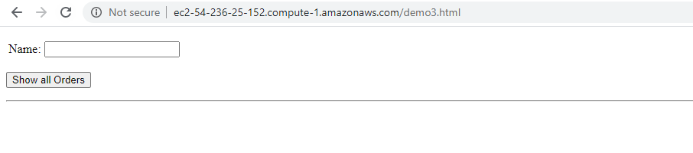

Here I entered last name and it displayed all orders placed by the customer where customer name contains “Galbreath”. As I used Ajax here, it displayed the orders without clicking any buttons nor pressing enter key. As soon as we enter the name, we get the customer details.

It works even if we give one or two letters of the Name.

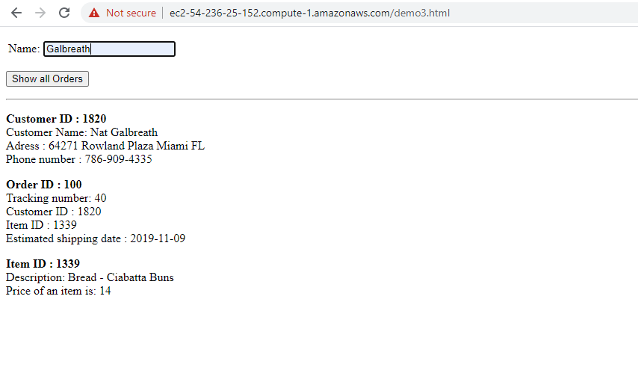

* This I clicked on ‘show all orders button’, it displayed all orders

